# Installing

Before we can begin setting up the servers, we need to install some things first.

Install Node.js from here:

<https://nodejs.org/en/download/>

Install XAMPP from here:

<https://www.apachefriends.org/download.html>

## Dependencies

After installing Node.js and XAMPP, we can install the dependancies for the project.

We will have to do this twice because the backend and frontend have separate dependancies

### Frontend

1. Navigate to the frontend folder:

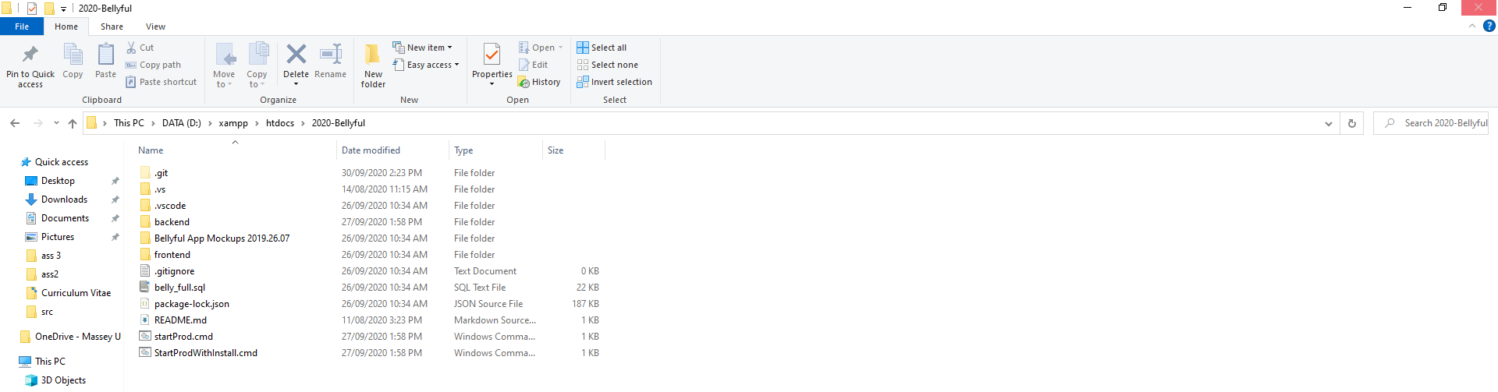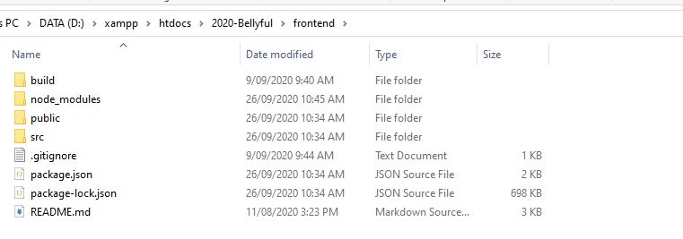

1. Highlight the navigation bar and open a terminal by typing “cmd” and pressing enter

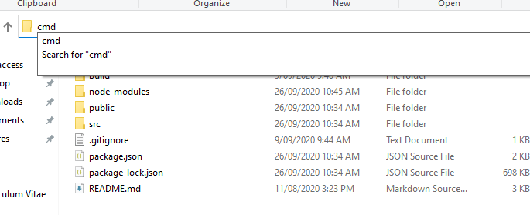

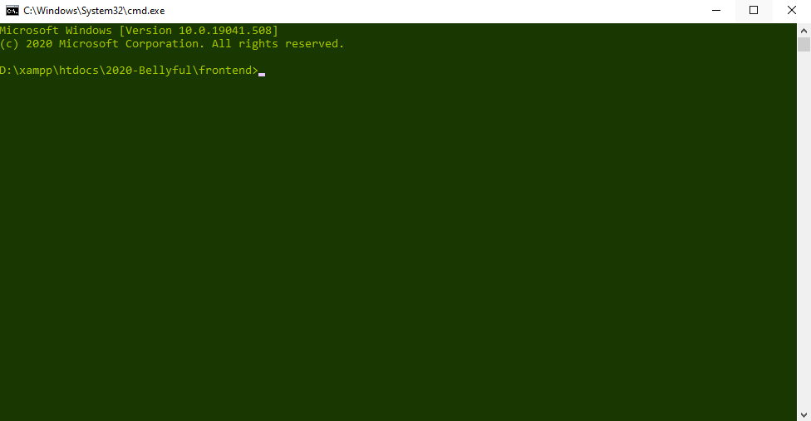

1. Type “npm install”, installing the dependancies required for the project (can take some time)

### Backend

1. Navigate to the backend folder

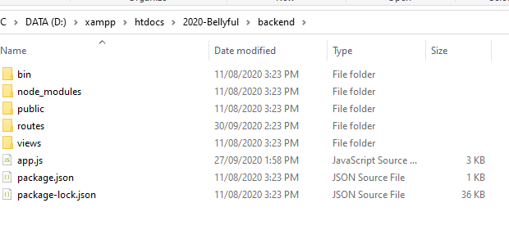

1. Open the console by typing “CMD” in the navigation bar

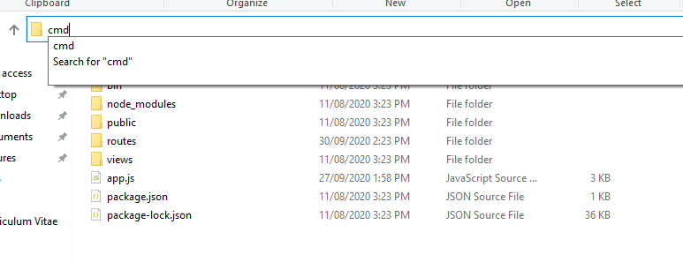

1. Run “NPM INSTALL” on the console



### MySQL server setup

After installing XAMPP, open the xampp console and start the mysql and apache processes.

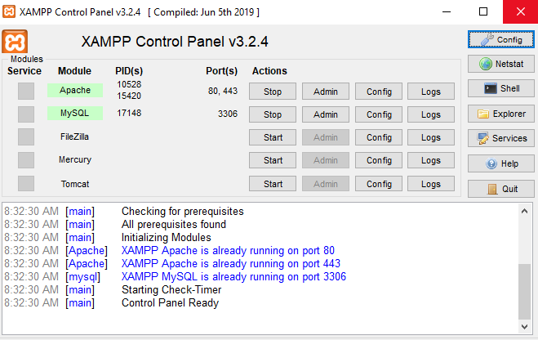

Once this is done, locate the belly_full.sql file in the main folder.

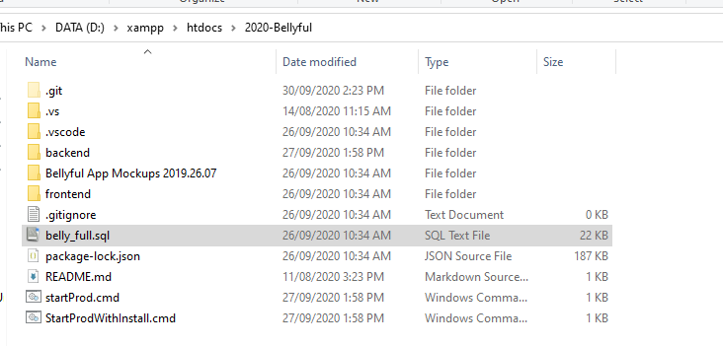

On a web browser, type in <http://localhost/phpmyadmin>

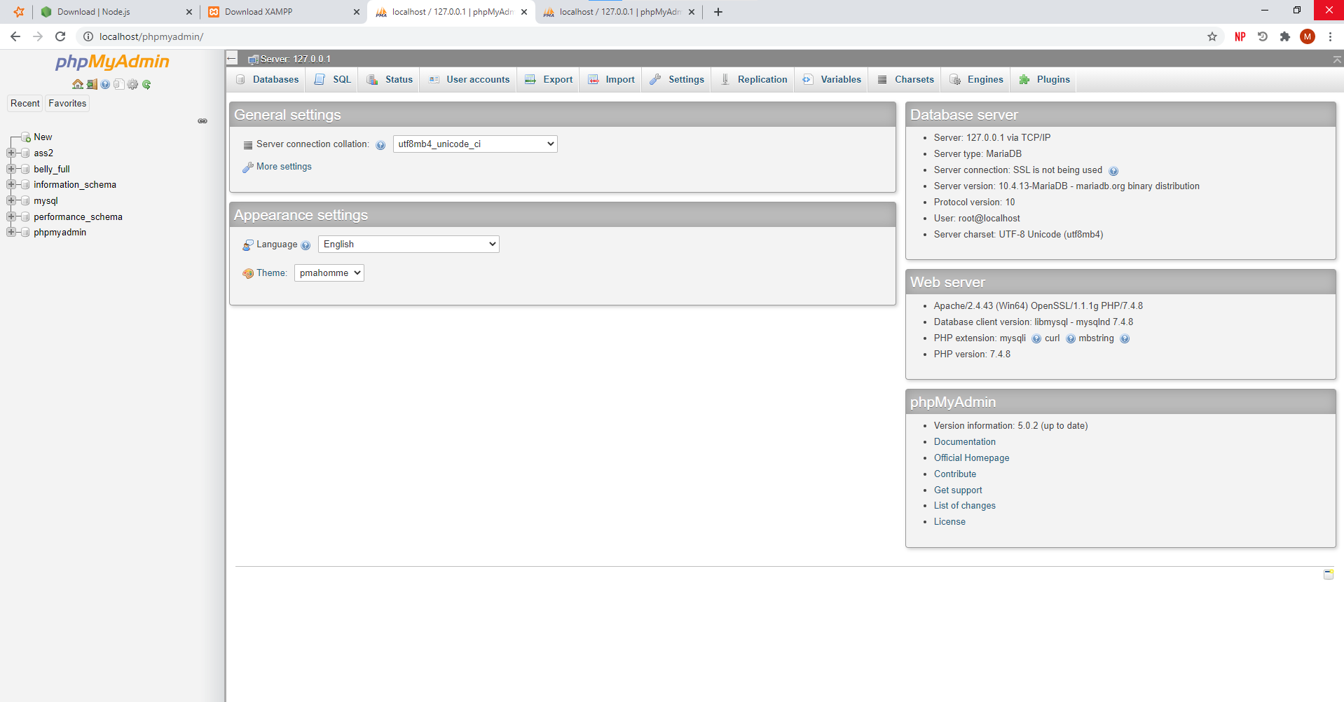

Find the import button on the top bar and click it



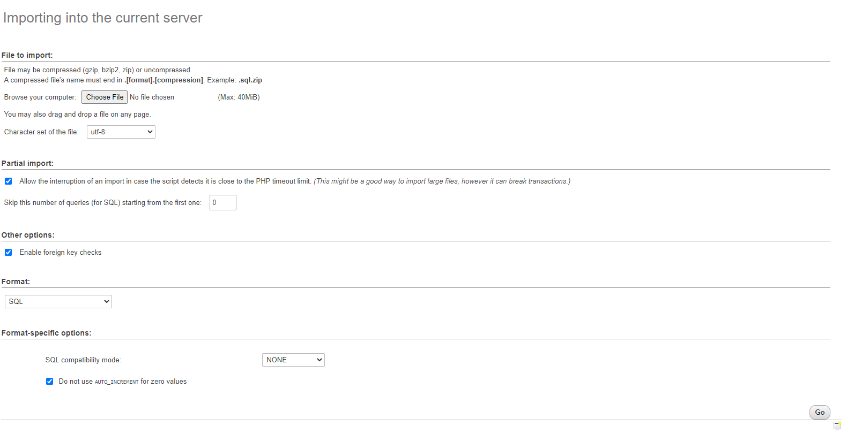

Click choose file and upload the belly_full.sql file here.

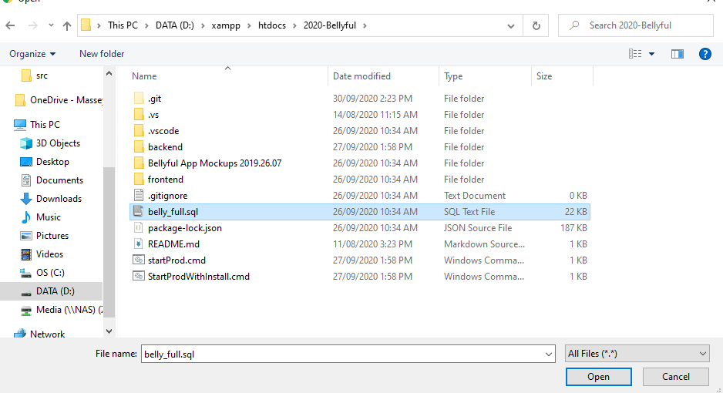

Finally hit “go”.

After this the setup is complete!

## Running the application

Find the batch file called “startProd.cmd”.

Run the batch file, it runs two commands on the terminal:

1. start cmd.exe @cmd /k "cd backend & npm start"
2. start cmd.exe @cmd /k "cd frontend & npm start"

This starts two terminals, navigates them to the frontend and backend and then starts the server.

The frontend will prompt you to ask if it should run on port 3001, accept it by typing “Y”.